An Android Application for Automobile

**NABEEL HASSAN**

DEPARTMENT OF COMPUTER SCIENCES

COMSATS UNIVERSITY ISLAMABAD,

ATTOCK CAMPUS – PAKISTAN

SESSION 2017-2021

An Android Application for Automobile

*Undertaken By:*

**Nabeel Hassan**

CUI/FA17-BCS-054/ATK

*Supervised By:*

**DR. YASIR ALI SHAH**

A DISSERTATION SUBMITTED AS A PARTIAL FULFILLMENT OF THE

REQUIREMENTS FOR THE DEGREE OF BECHELOR OF COMPUTER SCIENCE

DEPARTMENT OF COMPUTER SCIENCES

COMSATS UNIVERSITY ISLAMABAD,

ATTOCK CAMPUS – PAKISTAN

SESSION 2017-2021

**DECLARATION**

We hereby declare that this software, neither whole nor as a part has been copied out from any source. It is further declared that we have developed this software and accompanied the report entirely based on our efforts. If any part of this project is proved to be copied out from any source or found to be a reproduction of some other. We will stand by the consequences. No portion of the work presented has been submitted of any application for any other degree or qualification of this or any other university or institute of learning.

Nabeel Hassan

---------------------------

**CERTIFICATE OF APPROVAL**

It is to certify that the final year project of BS (CS) **“An Android Application for Automobile”** was developed by **Nabeel Hassan (CIIT/FA17-BCS-054/ATK)** under the supervision of **“Dr. Yasir Ali Shah”** and that in his opinion; it is fully adequate, in scope and quality for the degree of Bachelor of Science in Computer Sciences.

-------------------------------------------------------

**Supervisor**

-------------------------------------------------------

**External Examiner**

----------------------------------------------------

**Head of Department (Department of Computer Science)**

**Acknowledgment**

All praise is to Almighty Allah who bestowed upon us a minute portion of His boundless knowledge by virtue of which we were able to accomplish this challenging task.

We are greatly indebted to our project supervisor **“Dr. Yasir Ali Shah”**. Without his supervision, advice, and valuable guidance, completion of this project would have been doubtful. We are deeply indebted to them for their encouragement and continual help during this work.

And we are also thankful to our parents and family who have been a constant source of encouragement for us and brought us the values of honesty & hard work.

Nabeel Hassan

---------------------------

**PROJECT BRIEF**

PROJECT NAME AN ANDROID APPLICATION FOR AUTOMOBILE

ORGANIZATION NAME COMSATS UNIVERSITY ISLAMABAD, ATTOCK CAMPUS

OBJECTIVE PROVIDE AUTOMOBILE SERVICES TO USERS

UNDERTAKEN BY NABEEL HASSAN

CUI/FA17-BCS-054/ATK

SUPERVISED BY DR. YASIR ALI SHAH

LECTURER

COMPUTER SCIENCE

CUI, ATTOCK CAMPUS

STARTED ON OCTOBER 2020

COMPLETED ON EXPECTED JUNE 2021

COMPUTER USED LENOVO IDEAPAD 110,

3 COMPUTE CORES

2.0 GHZ PROCESSOR

4GB RAM

SOURCE LANGUAGE ANDROID, JAVA

OPERATING SYSTEM Windows 10

TOOLS USED ANDROID STUDIO, MS WORD

Contents

1

Introduction 1

1.1 *Application Introduction:* 2

1.2 *Scope of the Project* 2

2 Motivation and Scope 5

2.1 Canadian Automobile Association 5

2.2 Automobile Association App 5

Chapter 3 6

Requirement’s specification 6

3.1 Sign up for new user! 7

3.2 Login an Existing User 7

3.3 User Login Afterward 7

3.4 Forgot Password 7

3.5 Admin 7

3.6 Admins login 7

3.7 Use case diagram. 8

3.7.1 Start application 9

3.7.2 User Login 10

3.7.3 Search Service 10

3.7.4 Select Service 11

3.8 Admin use Case 11

3.8.1 Admin Select Service 11

3.8.2 Dialled numbers 12

3.8.3 Received numbers 12

Chapter 4 13

Project design 13

4 Project design 14

4.1 *Methodology* 14

4.2 *Design description* 14

4.3 *Sequence diagrams* 14

4.3.1 Register user 14

4.3.2 Login 15

4.3.3 Admin Login 16

4.3.4 Enter Service Provider Details 16

4.4 *Activity diagrams* 17

4.4.1 User Registration 17

4.4.2 Login user 18

4.4.3 Admin Login 19

4.5 Data flow diagram 20

5 Implementation 22

5.1 *Tools* 22

5.1.1 Android Studio 22

5.2 *Android SDK* 23

5.2.1 Firebase 23

5.3 *Development stages* 23

6 System Testing 33

6.1 *Unit Testing* 33

6.2 *System Testing* 33

7 Conclusion and Future Work 39

**Chapter 1**

# Introduction

## *Application Introduction:*

An Android application for Automobile is a smart android application that is used to provide basic services in automobile field. This application is a service provider application that provides services including Towing, Fuelling, Repairing, Lock smith and Battery Services. Similarly, user can contact whenever he needs a towing service to take the vehicle from one place to another in my case of emergency. This app saves the time of user by quickly providing them the selected service. Just like Towing service, all other services facilitate the user to overcome the daily issues by using our platform. This application provides services to the user at low and reasonable price as well as user can easily reach the destination. Our application has three modes: 1) Emergency service (Features: Taxi Towing, Repairing, Locksmith, Fuelling and Battery relevant Service.) 2) Normal service (Features: car washing, car tuning, car repairing) 3) Online shop (Features: Batteries change, Tyres change and Accessories) 4 An Android application for Automobile is a complete android-based platform and it will be accessible for everyone. There is no additional information required apart from mentioned ones and even in those required fields you must be precise. This platform is open for everybody, anyone can view the information on it but only the registered users can request the desired service. The administrator is controlling all operations using admin panel like approving the requests, adding the admin to take care of the system etc. If any request has any inappropriate information or any social norm is being broken than the administrator can delete the request.

**Problem Statement:**

Driver face tandem of emergency problems of automobile while driving i.e., mechanical or electrical fault or run out of Fuel or may be other problems i.e., battery problem, car cleaning etc. So, there is a dire need of system which can help drivers to overcome these problems and the system (app) developed by me will help the users to get rid of their problems**.**

## *Scope of the Project*

There are different modules used by the android application in order to get some certifiable result like all the service providers get registered by the admin itself and the each and every task is assigned from the admin office. By using the Users and Service provider details get saved in the Firebase database which meets the requirements of authentication of service providers.

1. Email and Password authentication.
2. Facebook and Instagram Login Authentication.
3. Resetting of the password in case of forgot the password.
4. Saving the user detail in the server.
5. Saving the Service provider details to the Server
6. Allows admin to Make a call to the service provider

**Chapter 2**

**Literature review**

In the current time frame, there are two famous web platforms which we found, that deal with this issue of our community. First platform is most famous one and it is an international organization called AAA (American Automobile Association). A second web platform is Canadian Automobile Association (CAA). In our country, there is no specific platform available which provide the reliable service related to Automobile Association.

# Motivation and Scope

We are proposing to develop an android-based solution that will help the peoples to get an automobile service but now, they can save their time through this application. They will be able to get access to the platform on a single click. The aim of this project is to facilitate the community by modern ways.

## Canadian Automobile Association

The Canadian Automobile Association commonly known as (CAA) is a non-profit federation, founded in 1913, of eight motor clubs across Canada, providing roadside assistance service, insurance services, and member discount.

## Automobile Association App

To design this portal, we have studied different websites of different countries that handled the different type of services. We have studied the mechanism of how they serve and work. We also asked a few people that how they would want the portal to be if they were using it. After analysing the mechanism and the layouts of different websites and keeping in mind the different suggestions given by the people, we got many ideas that how we can create our portal “An Android application for Automobile ".

Each day the app sends you a list of calls made and texts exchanged from the phone. Access your text messages from your computer anytime, see a clean log of text messages, calls with the time they were sent / received with the names from the phone contact list too. Configure the app to get all your text messages in your mail daily or weekly. Access to all your text and SMS messages at all time via your email. Access to your call logs so you know who you called at what time.

# Chapter 3

# Requirement’s specification

### 

## 3.1 Sign up for new user!

The costumers get registered with the database with their name, email and the password. All this work is done in the Firebase database using Internet Service. If the internet service is not available then the user cannot save his/ her with the application database.

## 3.2 Login an Existing User

The registered user can login and when a user get login it matches with the existing user. If the user is already registered the user will be able to login. If the user is not already registered then it shows that register with the application first.

## 3.3 User Login Afterward

After User Login, it shows the Interface where the User can select the required car Maintenance service and make a phone call to the admin and then the admin assigns the task to the mechanic.

## 3.4 Forgot Password

If a user forgets his password a page is available in the application, the user put its email address then the reset password will be sent to his email address provided by the user.

## 3.5 Admin

1. Administrator can add mechanics.
2. Administrator can add services.
3. Administrator can update services.
4. Administrator can delete mechanics/Service.

## 3.6 Admins login

Admins can login after he\she registered his\her name, email address, email password and phone number. The Admin Can Register new users/mechanics and their service also. All the work is done using the Firebase Database.

## 3.7 Use case diagram.

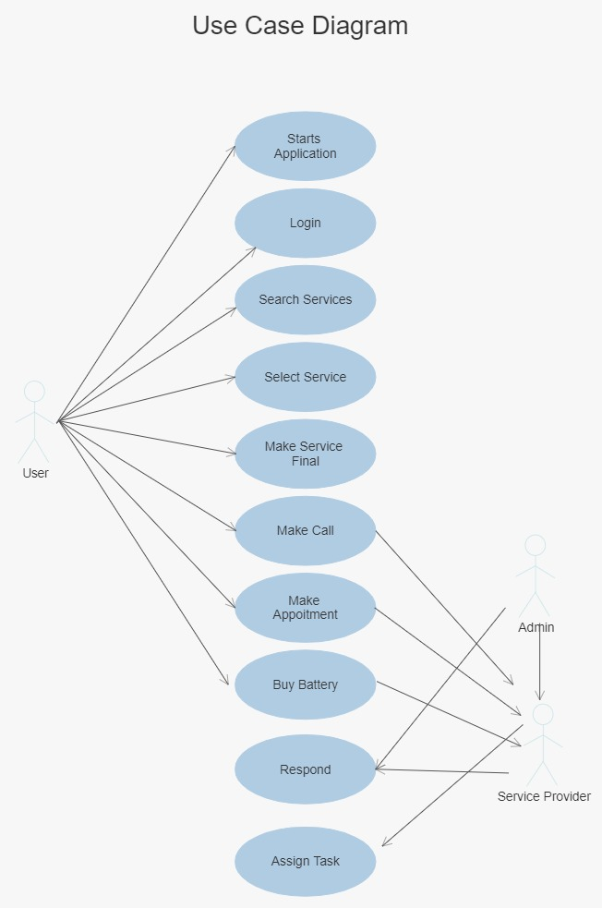

Fig 3.1: User Use Case Diagram

**Description**

In figure 3.1 the user get login and select login and search for the service. When the user selects the required service and make a call to admin. The admin picks up the call and give the task to the service provider. Then the Service provider entertain the User with the service.

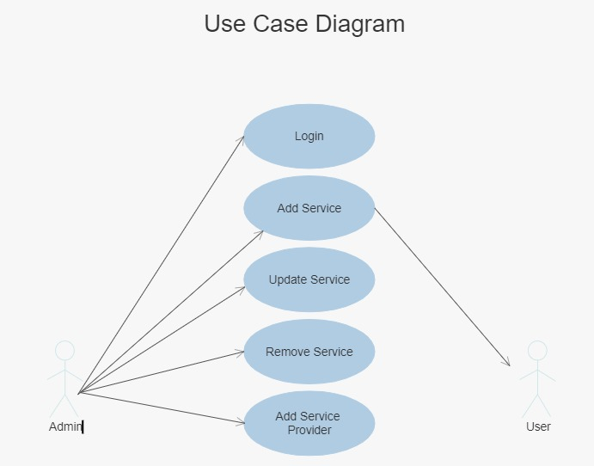

Fig 3.2: Admin Use Case Diagram

### 3.7.1 Start application

|  |  |
| --- | --- |
| **UC id:** | 1 |
| **Use case name:** | Start application |
| **Actor name:** | User |
| **Pre-condition:** | User have android phone and he must install application |
| **Post-condition:** | The App get Started |

### 3.7.2 User Login

|  |  |
| --- | --- |
| **UC id:** | 2 |
| **Use case name:** | Login |
| **Actor name:** | User |
| **Pre-condition:** | User can login into system with id and password |
| **Post-condition:** | User will login into system |

### 3.7.3 Search Service

|  |  |
| --- | --- |
| **UC id:** | 4 |
| **Use case name:** | Search Service Provider |
| **Actor name:** | User |
| **Pre-condition:** | User get Login |
| **Post-condition:** | User Search for Service |

### 3.7.4 Select Service

|  |  |
| --- | --- |
| **UC id:** | 5 |
| **Use case name:** | Select Service |
| **Actor name:** | User |
| **Pre-condition:** | User Searched Service |
| **Post-condition:** | Select Service and make Call to Admin |

## 3.8 Admin use Case

### 3.8.1 Admin Select Service

|  |  |
| --- | --- |
| **UC id:** | 6 |
| **Use case name:** | Admin Login |
| **Actor name:** | Admin |
| **Pre-condition:** | Admin Have Installed application |
| **Post-condition:** | Admin get login into app. |

### 3.8.2 Dialled numbers

|  |  |
| --- | --- |
| **UC id:** | 7 |
| **Use case name:** | Register Service Providers |
| **Actor name:** | Admin |
| **Pre-condition:** | Admin already login |
| **Post-condition:** | Admin Register the Service Providers |

### 3.8.3 Received numbers

|  |  |
| --- | --- |
| **UC id:** | 8 |
| **Use case name:** | Assign task |
| **Actor name:** | Admin |
| **Pre-condition:** | Admin Already Login |
| **Post-condition:** | Assign task to the Service provider |

# Chapter 4

# Project design

# Project design

## *Methodology*

We have chosen Mobile Application Development Lifecycle (MADLC) as we are developing mobile application and Mobile Application Development Lifecycle provides us phases for development. We used android studio for developing this application. It is a dedicated framework lifecycle for mobile. The proposed lifecycle includes the following phases: Identification, Design, Development, Prototyping, Testing and Maintenance. This lifecycle has been used for over a year in developing Android mobile applications. This lifecycle addresses some of the distinguishing characteristics of mobile applications like life span, complex functionalities, fewer physical interfaces, a greater number of screens for interaction, battery and memory usage, cross platform development and maintenance.

**Mobile Application Development Lifecycle Model (MADLC**)

As the mobile applications have complex functionality and are different from the desktop applications, the following Mobile Application Development Lifecycle model (MADLC) is proposed to enable a systematic approach in development.

## *Design description*

Following are the modules constituting the product to be developed.

Following are some diagrams of our module including.

* Sequence diagram
* Activity diagram
* Data flow diagram

## *Sequence diagrams*

### Register user

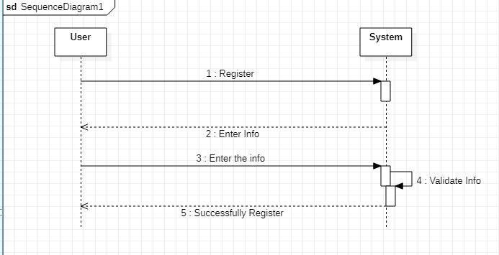

Fig 4.2: Sequence diagram of Registration

**Description**

A sequence diagram is an interaction diagram that show how object operate with one another and in what order. In figure 4.2 sequence diagram of register user. In this user register with their name email, phone no and password.

### Login

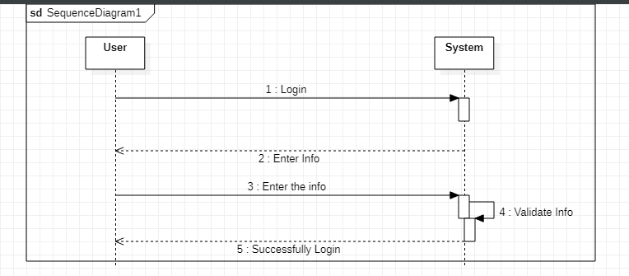

Fig 4.3: Sequence diagram of login

**Description**

In figure 3 there are 3 lifelines including user login. User enter email and password, then successfully get login Int System.

### Admin Login

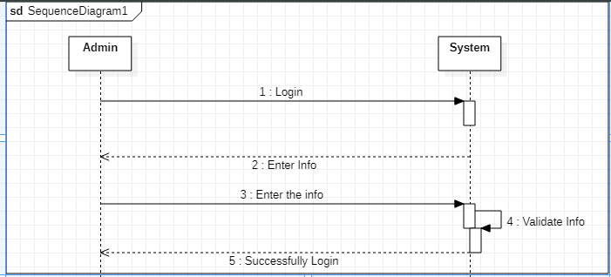

Figure 4.4: Sequence diagram of Admin Login

**Description**

In figure 3 there are 3 lifelines including user login. User enter email and password, then successfully get login Into System.

### Enter Service Provider Details

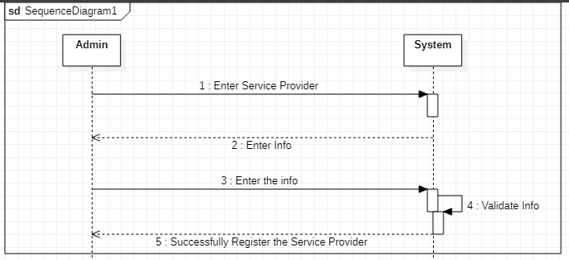

Fig 4.5: Sequence diagram of Service Provider Registration

**Description**

In figure 4.5 there are 3 lifelines including Admin, devise and database. When Admin logging into system the service providers details will be saved by the admin into system.

## *Activity diagrams*

### User Registration

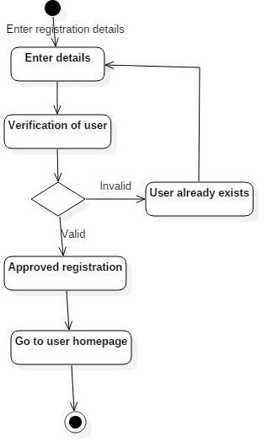

Fig 4.6: Activity diagram of register user

**Description**

In figure 4.6 users register with the system. User enter their name and password than system verifies user account if user already exists than go back to enter details. If user not already exists than its registration is approved and homepage is open.

### Login user

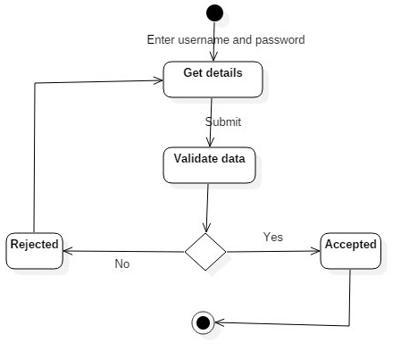

Fig 4.7: Activity diagram of login use

**Description**

In figure 7 user enter their name and password, if the password is correct than user logging into system, if name or password is incorrect than user again enter name or password.

### Admin Login



Fig 4.8 Activity diagram of Admin Login

**Description**

In figure 4.5 user enter their name and password, if the password is correct than user logging into system, if name or password is incorrect than user again enter name or password.

## Data flow diagram

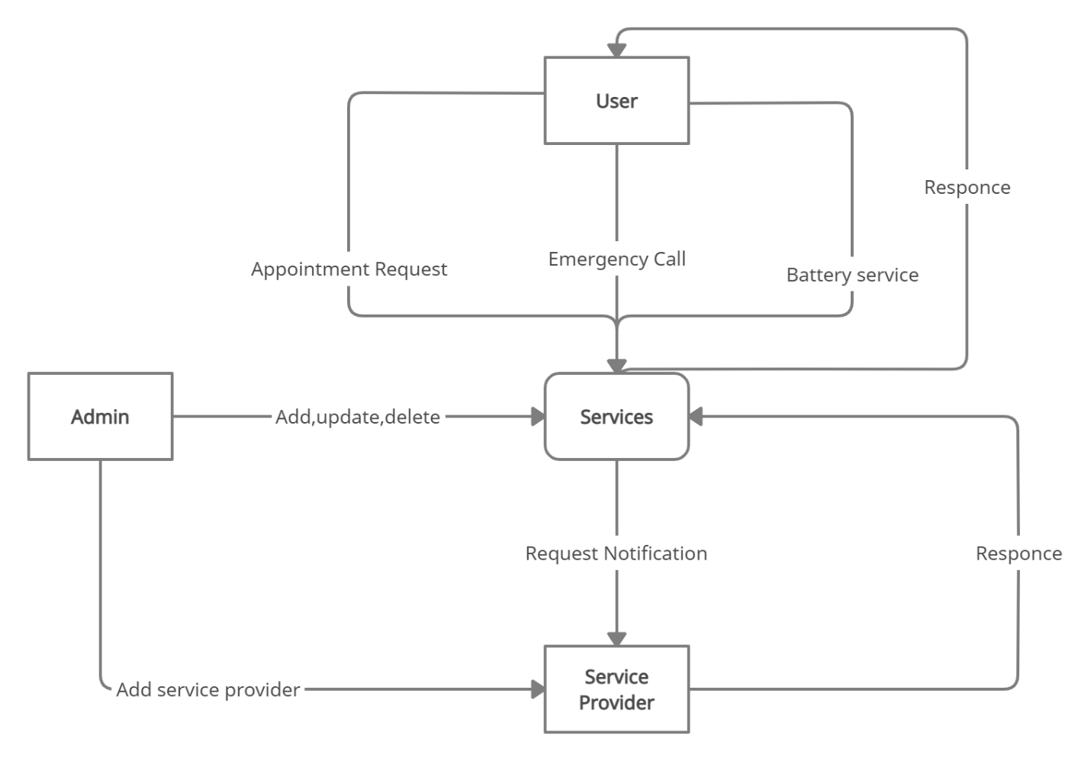

Fig 4.9Data Flow diagram

**Chapter 5**

**Implementation**

# Implementation

This chapter is the overview of the different tools used in the development of application and the important stages through the development process. For the development of the project “**Android Application for Automobile**” some of the important implemented stages mention in this chapter and the different tool that are used and that are listed below. 5.1

## *Tools*

* Android Studio
* Firebase

### Android Studio

Android Studio is the official integrated development environment for Google's Android operating system, built on JetBrains' IntelliJ IDEA software and designed specifically for Android development.

Android Studio is also the fastest developer tools for building market-leading apps and accelerating performance. With an intelligent code editor, flexible build system, real-time profilers and emulators. Building without limits. Creating the best code. Build rich experiences.

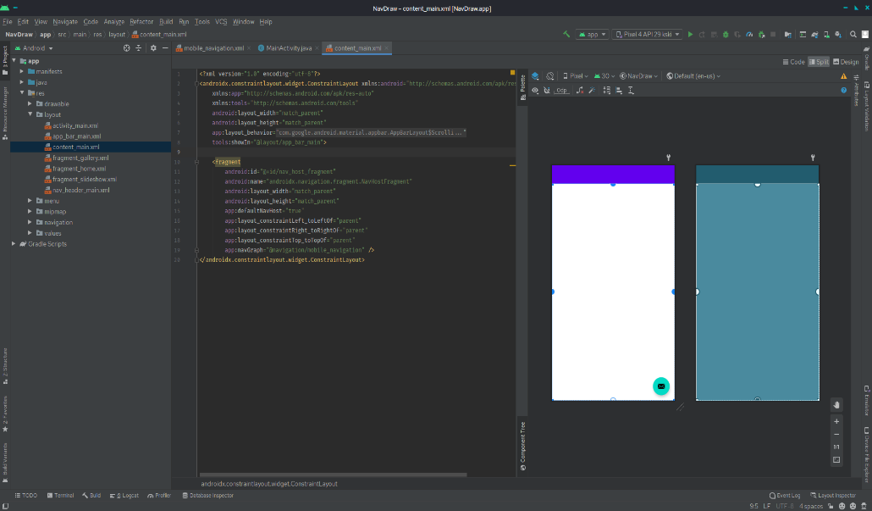

**Figure 5.1- Android Studio Interface**

## *Android SDK*

The Android programming advancement unit consolidates a total plan of change gadgets. These join a debugger, libraries, a handset emulator considering QEMU, documentation, test code, and instructional activities. Starting at now supported change stages consolidate PCs running Linux (any front-line work zone Linux allocation), Mac OS X 10.5.8 or later, Windows XP or later; for the event, one can make Android programming on Android itself by using [AIDE - Android IDE - Java, C++] application and [Android java editor] application.

### Firebase

**Firebase** is a Backend-as-a-Service (Baas). It provides developers with a variety of tools and services to help them develop quality apps, grow their user base, and earn profit. It is built on Google’s infrastructure. Firebase is categorized as a NoSQL database program, which stores data in JSON-like documents. Firebase already exists. Firebase is a global server, and we can access worldwide.

## *Development stages*

* Our project is developed in below stages which are given below stage.
* First screen show
* User or client signup
* User or Client Login
* User Service Selection
* Admin Signup
* Admin Service Addition
* Service provider
* User
  1. **First screen**

When we start app first screen look like this.

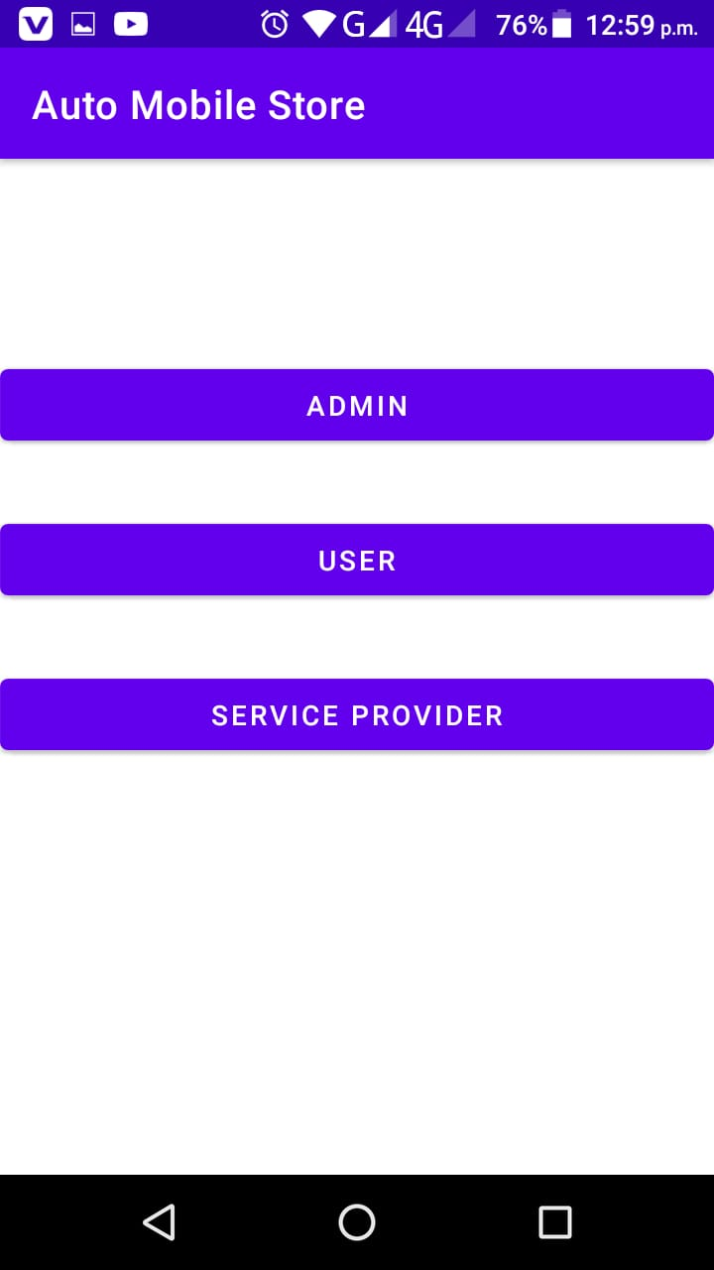

* 1. **User or client signup**

If the client or user is not already registered, then User or Client is also able to be registered with system Database via Email.

As If User is not able to fill up the required the Edit Text Field, then a proper UI Toast tell the User to fill up the Fields properly.

This will able to help user to get a proper signup in a correct manner. After adding all of the above the Fields properly the Data got saved in Database properly like this. This Might Help the Admin to Work properly with the clients.

* 1. **User or client Login**

After Successful user signup the user is allowed to go through the app via User login. As of Enter proper details the user got redirected to the Main UI of the app where the user can get select the required service that the user wants, and Admin is providing its user with that.

* 1. **Main Dashboard**

After successful login User May See Dashboard and able to select the Required Service provided by admin. The all of the below services can be edited by the admin side anytime If the service is not available.

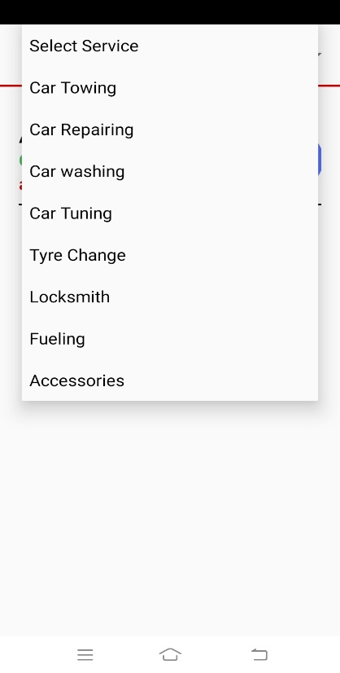

* 1. **Service Selection**

After service selection user may able to contact with service provider via phone. After the contact the admin able to help the user to initiate a response in response for the user.

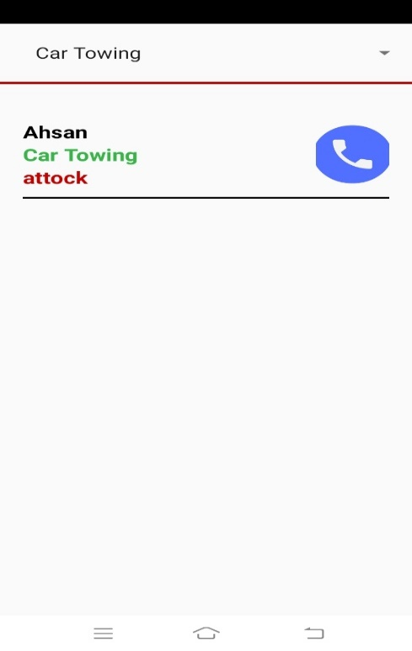

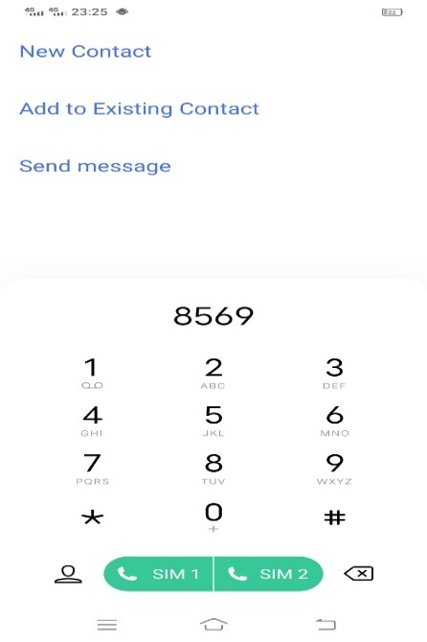

* 1. **Admin Login**

Admin have entire hold over the app and is been able to add or remove service that the company have available and admin is only able to add or remove that services just after successful login.

The admin just login just like client but the main difference is it only deal with admin table in database.

The UI of admin Login as same as the Client login but the difference is providing the services.

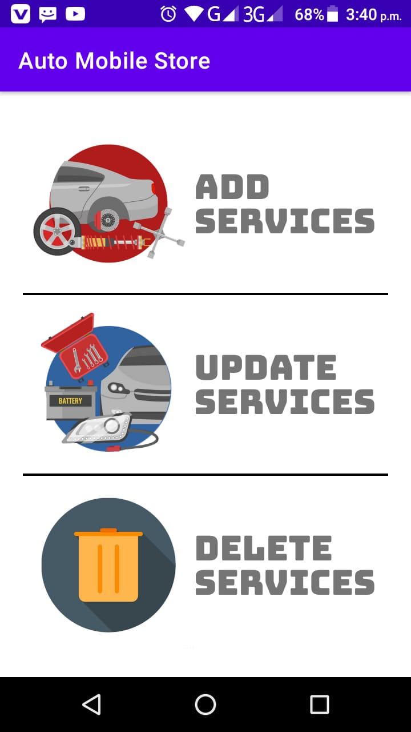

* 1. **Admin Main Dashboard**

After successful login Admin got redirected to Admin Dashboard that contains the add service, update or remove a particular service. Admin is been able to select the option whatever he wants.

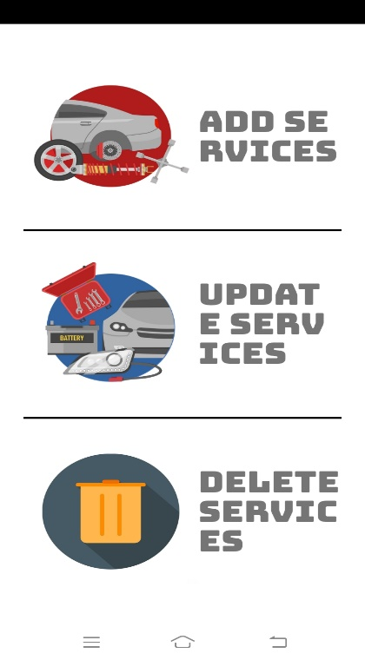

* 1. **Add Service**

Admin in here can add a service and have a choice to put in category what necessary. 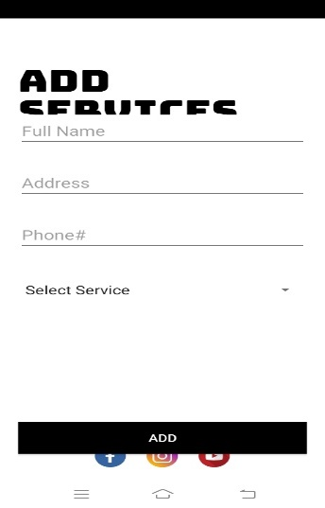

* 1. **Update Service**

Admi is able to update the service if is necessary. In order to update user is required to get this more efficiently if the Admin find out necessary and same thing goes to client side and also able to delete a particular service.

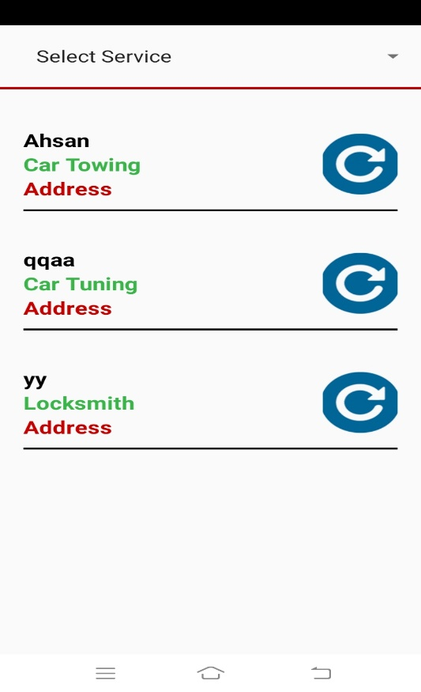

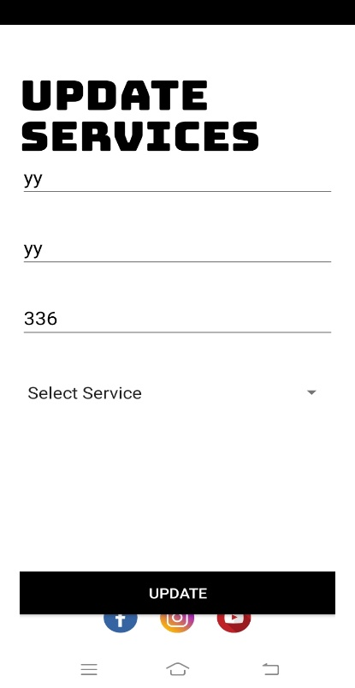

* 1. **Service provider**

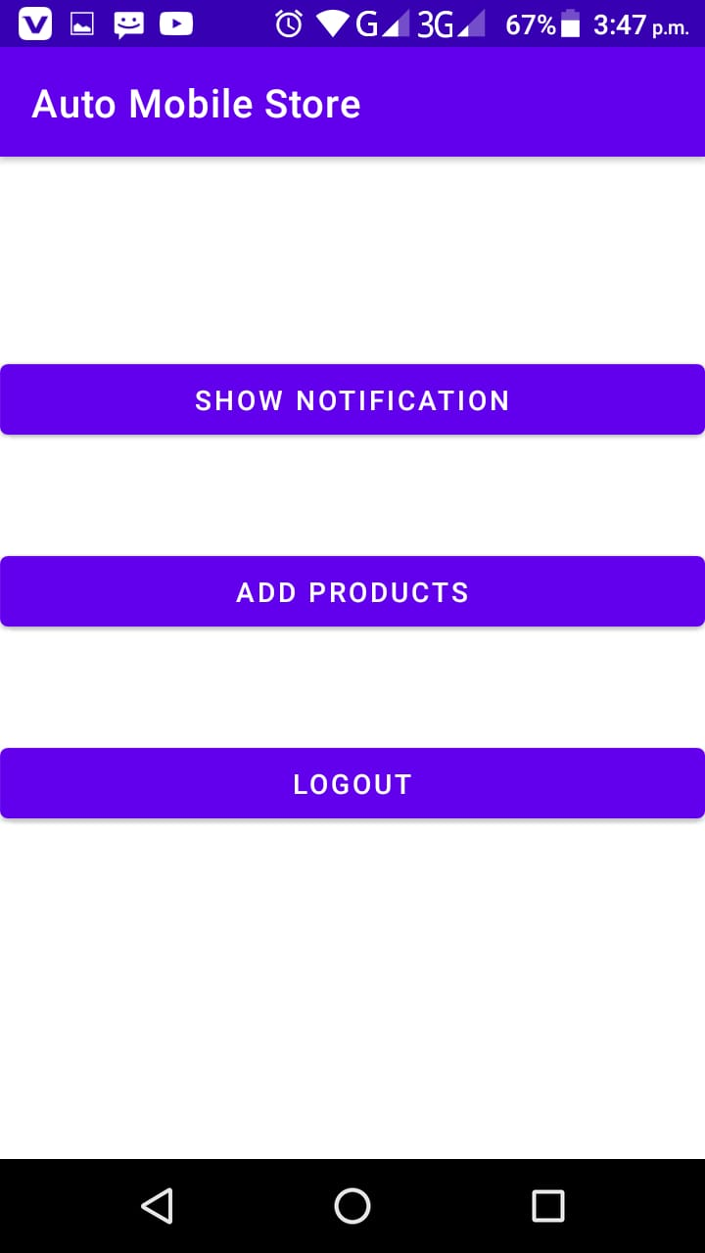

* 1. **User**

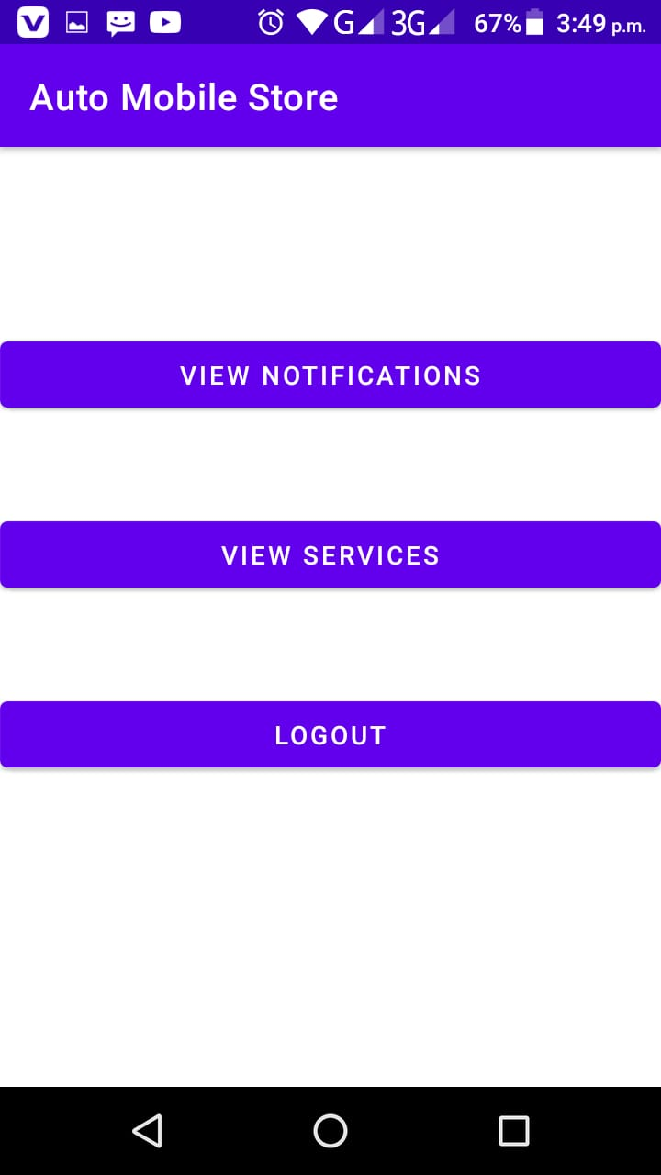

**CHAPTER 6**

**SYSTEM TESTING**

# System Testing

In system testing a complete and integrated system is tested. Our focal point throughout the designing and implementation was to test each unit. User activities regarding with user’s registration properly tested and stored in database. Validation and verification are very important process where we will validate each module in case if user enter any wrong entry in desired field.

## *Unit Testing*

IT’S a level where we test each individual component while being developed for the conformance to desired requirement. This testing was applied to both feedback and registration portions in case if our user enters some incorrect value then a message will be shown to put correct entry. We applied validation process on our input field. we also check the conformance of correct value to be entered in database.

## *System Testing*

We have focused on thorough testing through-out the design and implementation phase while testing the user and admin all the other activity that they perform should be stored in database. Evaluation contains the testing of each and every module of the system and checking the errors which occur into the database while putting some entries into it or the interface problem.

|  |  |  |  |
| --- | --- | --- | --- |
| Steps | Actions | Expected System Response | Pass/Fail |
| 1 | Users enter Invalid email | Show error message “Please enter valid email. | Fail |
| 2 | User enter invalid password. | Show error message “Please enter valid password | Fail |
| 3 | Enter valid password |  |  |
| 4. | Users click on login button | System displays the home page of App | Pass |

|  |  |  |  |
| --- | --- | --- | --- |
| Steps | Actions | Expected System Response | Pass/Fail |
| 1 | Users enter Invalid email type | Show error message “Please enter valid email. | Fail |
| 2 | User enter invalid password. | Show error message “Please enter valid password | Fail |
| 3 | Enter valid email |  |  |
| 4. | Miss the fields button | System displays the home page of App | Pass |
| 5 | Users click on Signup | System displays the home page of App |  |

|  |  |  |  |
| --- | --- | --- | --- |
| Steps | Actions | Expected System Response | Pass/Fail |
| 1 | Make internet disconnect | Show error message “Please enter valid email or check internet. | Fail |
| 2 | User enter valid password. | Show error message “Please enter valid password | Fail |
| 3 | Enter valid email and no internet |  |  |
| 4. | Miss the fields button | System displays the home page of App | Pass |
| 5 | Users click on Signup and connect internet | System displays the home page of App | Pass |

|  |  |  |  |
| --- | --- | --- | --- |
| Steps | Actions | Expected System Response | Pass/Fail |
| 1 | Make internet disconnect admin side | Show error message “Please enter valid email or check internet. | Fail |
| 2 | Admin enter valid password. | Show error message “Please enter valid password | Fail |
| 3 | Enter valid email and no internet | No Response and internet error | Fail |
| 4. | Miss the fields button | System displays the home page of App | Pass |
| 5 | Users click on Signup and connect internet | System displays the home page of App | Pass |

|  |  |  |  |
| --- | --- | --- | --- |
| Steps | Actions | Expected System Response | Pass/Fail |
| 1 | Make internet disconnect Add Service | Show error message “Not able to add data”. | Fail |
| 2 | Admin not filled the fields. | Show error message “Please enter parameters” | Fail |
| 3 | Enter all fields and no internet | No Response and internet error | Fail |
| 4. | Add service parameters and have internet |  |  |
| 5 | Add service parameters and have internet | Show response “service added successfully” | Pass |

|  |  |  |  |
| --- | --- | --- | --- |
| Steps | Actions | Expected System Response | Pass/Fail |
| 1 | Make internet disconnect remove Service | Show error message “Not able to add data”. | Fail |
| 2 | Admin not filled the fields. | Show error message “Please enter parameters” | Fail |
| 3 | Enter all fields and no internet | No Response and internet error | Fail |
| 4. | Remove service parameters and have internet |  |  |
| 5 | Remove service parameters and have internet | Show response “service removed successfully” | Pass |

|  |  |  |  |
| --- | --- | --- | --- |
| Steps | Actions | Expected System Response | Pass/Fail |
| 1 | Make internet disconnect update Service | Show error message “Not able to add data”. | Fail |
| 2 | Admin not filled the fields. | Show error message “Please enter parameters” | Fail |
| 3 | Enter all fields and no internet | No Response and internet error | Fail |
| 4. | update service parameters and have internet |  |  |
| 5 | update service parameters and have internet | Show response “service updated successfully” | Pass |

|  |  |  |  |
| --- | --- | --- | --- |
| Steps | Actions | Expected System Response | Pass/Fail |
| 1 | User internet disconnect and goes to Main dashboard | No data showed | Fail |
| 2 | Select parameter that contains no data | No data showed | Pass |
| 3 | No internet and no data | No data showed | Fail |
| 4. | Connect to internet and have data |  |  |
| 5 | Having internet and data | Data Showed | Pass |

**Chapter 7**

**Conclusion and Future Work**

# Conclusion and Future Work

Drivers get various problems while driving their automobile, so in order to get them out of this havoc, we had undertaken this very project. In this project, we developed an Android application based on Automobile services, which will surely help the driver to avail the basic services in automobile field. This application is a service provider application which help driver to get different services including Towing, Fuelling, Repairing, Lock smith and Battery Services. Similarly, user can contact whenever he needs a towing service to take the vehicle from one place to another in my case of emergency. This app saves the time of user by quickly providing them the selected service. Just like Towing service, all other services facilitate the user to overcome the daily issues by using our platform. This application provides services to the user at low and reasonable price as well as user can easily reach the destination. So by keeping this in mind, we designed the Android application for automobile with firebase. There are three type of users of this system: Admins, Service provider and User.

**7**.**2 Future Work**

* We have Next plan to work with GPS and Mobile Location service for both parties and show them over map so that the Service provider and user can coordinate even better.
* We can add automobile salespersons feature. User can easily buy and sell a car in one platform.
* We are hiring a mechanics, locksmith persons and tire related persons who must specialized in this said fields.

**7.2.3 Recommendations**

We can used different algorithms for the recommendations using the different parameters like we Conclusion and Future Work 117 use user buying products parameter to predict the products with different technique.

**References**

1. <https://en.wikipedia.org/wiki/Android_Studio>
2. <https://www.javatpoint.com/android-intent-tutorial#:~:text=Android%20Intent%20is%20the%20message,intent%20is%20intention%20or%20purpose>
3. <https://en.wikipedia.org/wiki/XAMPP>
4. <https://en.wikipedia.org/wiki/Kotlin_(programming_language)>
5. <https://en.wikipedia.org/wiki/Java_(programming_language)>
6. <https://www.javatpoint.com/android-intent-tutorial#:~:text=Android%20Intent%20is%20the%20message,intent%20is%20intention%20or%20purpose>
7. <https://www.w3schools.com/sql/sql_intro.asp>
8. <https://docs.microsoft.com/en-us/sql/ssms/quickstarts/ssms-connect-query-sql-server?view=sql-server-ver15>
9. <https://docs.microsoft.com/en-us/sql/relational-databases/lesson-1-connecting-to-the-database-engine?view=sql-server-ver15>